- Taïo Linked Server:
sp_addlinkedserver [ @server = ] 'server'
[ , [ @srvproduct = ] 'product_name' ]
[ , [ @provider = ] 'provider_name' ]
[ , [ @datasrc = ] 'data_source' ]
[ , [ @location = ] 'location' ]
[ , [ @provstr = ] 'provider_string' ]
[ , [ @catalog = ] 'catalog' ]

Arguments
[ @server = ] 'server'
Is the local name of the linked server to create. server is sysname, with no default.
With multiple instances of SQL Server, server may be servername\instancename. The linked server then may be referenced as the data source for
SELECT *FROM [servername\instancename.]pubs.dbo.authors.
If data_source is not specified, server is the actual name of the instance.
[ @srvproduct = ] 'product_name'
Is the product name of the OLE DB data source to add as a linked server. product_name is nvarchar(128), with a default of NULL. If SQL Server, provider_name, data_source, location, provider_string, and catalog do not need to be specified.
[ @provider = ] 'provider_name'
Is the unique programmatic identifier (PROGID) of the OLE DB provider corresponding to this data source. provider_name must be unique for the specified OLE DB provider installed on the current computer. provider_name is nvarchar(128), with a default of NULL. The OLE DB provider is expected to be registered with the given PROGID in the registry.
[ @datasrc = ] 'data_source'
Is the name of the data source as interpreted by the OLE DB provider. data_source is nvarchar(4000), with a default of NULL. data_source is passed as the DBPROP_INIT_DATASOURCE property to initialize the OLE DB provider.
When the linked server is created against the SQL Server OLE DB provider, data_source can be specified in the form of servername\instancename, which can be used to connect to a specific instance of SQL Server running on the specified computer. servername is the name of the computer on which SQL Server is running, and instancename is the name of the specific SQL Server instance to which the user will be connected.
[ @location = ] 'location'
Is the location of the database as interpreted by the OLE DB provider. location is nvarchar(4000), with a default of NULL. location is passed as the DBPROP_INIT_LOCATION property to initialize the OLE DB provider.
[ @provstr = ] 'provider_string'
Is the OLE DB provider-specific connection string that identifies a unique data source. provider_string is nvarchar(4000), with a default of NULL. provstr is passed as the DBPROP_INIT_PROVIDERSTRING property to initialize the OLE DB provider.
When the linked server is created against the SQL Server OLE DB provider, the instance can be specified using the SERVER keyword as SERVER=servername\instancename to specify a specific instance of SQL Server. servername is the name of the computer on which SQL Server is running, and instancename is the name of the specific SQL Server instance to which the user will be connected.
[ @catalog = ] 'catalog'
Is the catalog to be used when making a connection to the OLE DB provider. catalog is sysname, with a default of NULL. catalog is passed as the DBPROP_INIT_CATALOG property to initialize the OLE DB provider.

Return Code Values
0 (success) or 1 (failure)
Ví dụ: Giả sử ta đã tạo 1 login tên ‘kythu’, pass ‘123’ ở THU-PC\SERVER2 với quyền db_datareader trên cơ sở dữ liệu QL_VATTU; Trên Server THU-PC\TINTIN , ta sẽ tạo 1 tạo linked server ‘TOSERVER2’ đến THU-PC\SERVER2 để 1 user bất kỳ trên phân mảnh thuộc Server THU-PC\TINTIN có thể truy cập đến cơ sở dữ liệu QL_VATTU.
USE master
GO
-- To use named parameters:
use master
EXEC sp_addlinkedserver
@server='TOSERVER2', @srvproduct='',
@provider='SQLOLEDB',
@provstr = 'DRIVER={SQL Server};SERVER=THU-PC\SERVER2;UID=kythu;PWD=123;'
GO

Trong trường hợp ta muốn tạo linked server qua giao diện thì :
- Connect vào Server THU-PC\TINTIN , right click Server Object, right click Linked Servers, chọn New Linked Server:
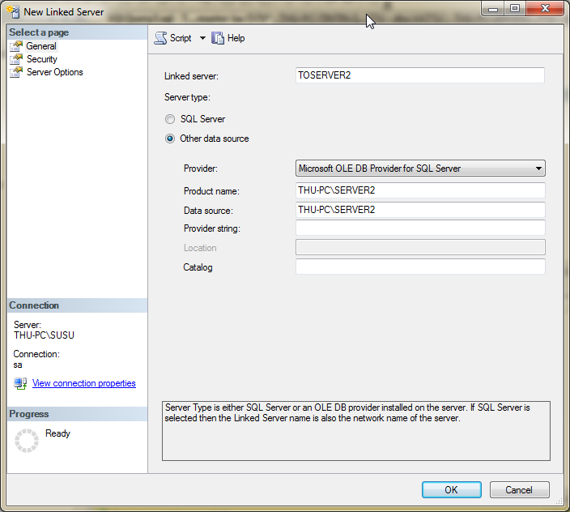

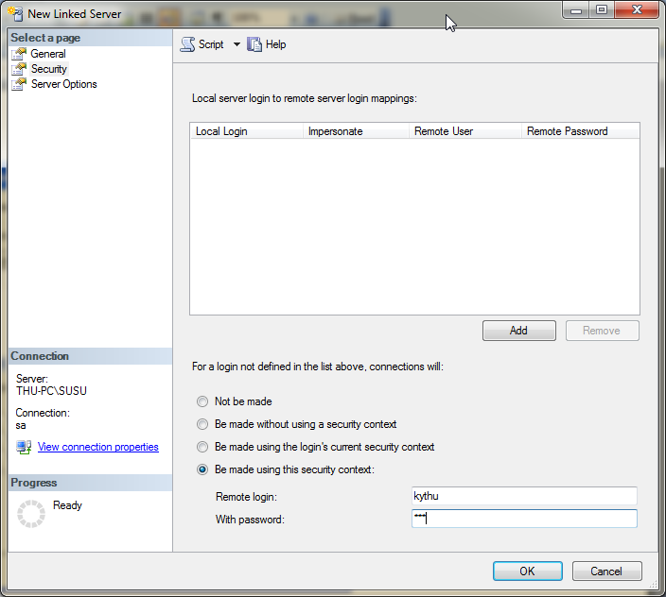

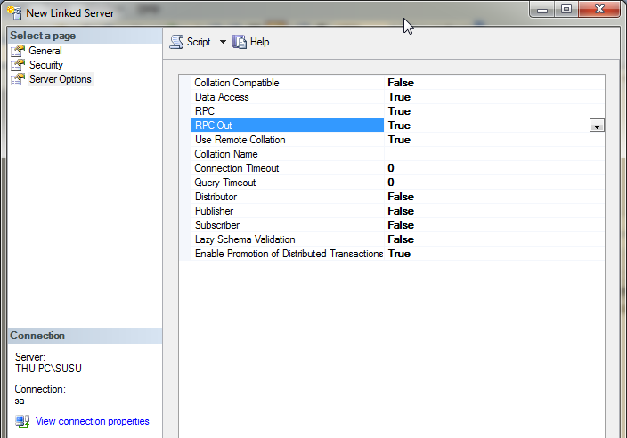

Sau khi tạo xong Linked Server , ta kiểm thử bằng cách đứng ở Server THU-PC\TINTIN ,
SELECT * FROM TOSERVER2.QL_VATTU.DBO.NHANVIEN

- a/ Lieät keâ caùc sinh vieân thi chöa ñaït laàn 1 moân ‘LTVB’
Lieät keâ caùc ñôn ñaët haøng do nhaân vieân coù maõ =2 nhaän.
select orderid, C.CustomerID, CompanyName
from Home.Northwind_Customer_Other.dbo.Orders O, Home.Northwind_Customer_Other.dbo.Customers C
where O.CustomerID= C.CustomerID and O.EmployeeID=2

Union
select orderid, C1.CustomerID, CompanyName
from duonglan1.Northwind_Customer_UK.dbo.Orders O1, duonglan1.Northwind_Customer_UK.dbo.Customers C1
where O1.CustomerID= C1.CustomerID and O1.EmployeeID=2

b. Lieät keâ dssv cuûa lôùp ‘TH01’
if exists ( select * from Home.Northwind_Customer_Other.dbo.Orders
where OrderID=10249)
select * from Home.Northwind_Customer_Other.dbo.Orders O
where OrderID=10249
else
if exists ( select * from Duonglan1.Northwind_Customer_UK.dbo.Orders
where OrderID=10249)
select * from Duonglan1.Northwind_Customer_UK.dbo.Orders
where OrderID=10249
else raiserror ('Khong co don dat hang ban chon',16,10)
e/ Thoáng keâ só soá cuûa sinh vieân toaøn tröôøng:
select country, count(*) from home.northwind_customer_other.dbo.customers
group by country
union
select country, count(*) from duonglan1.northwind_customer_uk.dbo.customers
group by country

